### *BOARD OF COMMISSIONERS*

## Justin Douglas. CHAIRMAN

## Mike Pries, VICE CHAIRMAN

## George P. Hartwick III, SECRETARY

### *CHIEF CLERK/CHIEF OF STAFF*

VINCE PAESE

***DIRECTOR OF HUMAN SERVICES***

RANDIE YEAGER

***SOLICITOR***

MATTHEW OWENS

MHADP ADMINISTRATOR

ANDREA KEPLER

DAUPHIN



COUNTY

DEPARTMENT OF MENTAL HEALTH / AUTISM / DEVELOPMENTAL PROGRAMS

100 CHESTNUT STREET, HARRISBURG, PA 17101

(717)780-7050 / (717)780-7061 FAX

**MEETING DATE:** January 28, 2025, 8:30AM

**MEETING PLACE:** Virtual

**ATTENDANCE:**

**Board Members present:**

Travis Waters, Nancy Sajeski

**Board Members absent:**

Commissioner Hartwick, Marge Chapman, Cheryl Tierney, Brandy Fox, Amy McPhilemy, Wendy Johnson, Diane Bates-Sier and Robert Jenkins

**Providers:** Brenda Laubach, Jessica Paul, April Downing, Ashley Stagl, Beth-Ann McConnell, Beth Fox, Bonnie Kent, Holly Karalus, Janeen Latin, Jenna Lyter, Jessica Paul, Jill Nelson, Jim Martin, John G. Frain, Karen Speece, Kathy Carr, Kelsey Kinney, Kris Saylor, Kristin Rocourt, Laura Tieman, Lindsey Lowenfeld, Liz Salsgiver, Mamie Smith, Maria Speca, Marlai Paxton, Mary Beth Greenhalgh, Mary Lenhart, Michelle Stagmer, Nguyen Nguyen, Nick Eckman, Nick McConnell, Nicole Brantner, Patrick Slattery, Rachel Keen, Saran Tucker, Shannon Williard, Susan Jacobs, Tanya Crane, Tom Fink, Marla Langley and Steph Iseman

**MHADP Staff:** Andrea Kepler, Rachael Clifton, Paul Geffert, Rachael Clifton, Dave DeSanto, Frank Magel, Julie Peters, Robin Baldwin, Sherie Arias, Sufyan Baig, Tammy Shoff and Mary DeCoen

1. **Welcome and Introductions.**
2. **Approval of the November 26, 2024 MHADP Advisory Board Meeting Minutes-** Meeting minutes were not approved due to the lack of a quorum and will be tabled until the next meeting. Due to these circumstances, an informational Board meeting only was held.
3. **Additions to the Meeting Agenda**
4. **Administrator’s Report**

**Autism/Developmental Program Services:**

* **Incident Management** continues to be a high priority in terms of ensuring consumers’ health and safety and ensuring investigations and other related activities are completed in a timely manner. Dauphin AE and CMU continue to make progress with finalizing overdue incident reports and implementing an incident fidelity process to compare ER and hospitalization claim data with incidents entered to EIM to identify potential concerns of abuse or neglect as well as to ensure that critical incidents are being reported. We had 105 reportable incidents and 52 required a Certified Investigator to investigate the nature of the incident.
* ADP continues to participate in the monthly **Provider Applicant Orientation Training** in collaboration with the Office of Developmental Programs (ODP) and assist new providers with activities related to ODP provider qualification. We have 1 new

provider this month, (community based) who submitted all their paperwork, and we issued their DP1059. We did have 4 providers who have passed the initial test, and we are waiting for them to submit their paperwork. We have 3 who are ongoing in sending their paperwork.

* **Requalification**. Next Spring/2025 will be the next period for requalification.
* **Annual Independent Monitoring for Quality (IM4Q)** We have a total of 98 individuals for the 24/25 survey. We will be working with our contracted vender CILO to review information for the 24/25 fiscal year. CILO has started to outreach to Individuals/Families, to begin interviewing. There was a recent change in how we pay for IM4Q Monitoring. The pre surveys also have been updated and completed for all 98 individuals that were picked. Interviews are scheduled and updated daily.
* **Annual QA&I**

We had a total of 17 QA&I providers. We finished our interviews in November. We are waiting for several providers that need to establish for their agency a certified investigator. They need to submit an email to Dauphin County that they have signed up for the training. When they receive their completion certificate, they will be confirmed “complete” in passing their QA&I review.

* **ID Committee:** Meeting took place on Dec 3rd at noon at, 900 Arlington St Harrisburg Pa. 17101. It was a smaller group, with most participants having other conflicting meetings. We updated some of the mission and vision of this group. The plan is to review and update the mission and address how the group will be sharing information of concern with other families. Our next meeting will be on February 4th at noon. We are hoping to have our regular meetings back at CMU/ Pathways Forward 1100 S Cameron St Harrisburg Pa. 17104
* **Community Outreach** – Dauphin County MHADP volunteered at the Harrisburg Autism Society’s Holiday event, Dec 8th
* **Intake**

For the month of December 2024, Pathways Forward received 15 calls or walk-ins from individuals/families inquiring about services. They completed 21 intakes.

Inquiry Language- 15 English

Intake Language- 15 English

                4 Nepali

                 1 Spanish

                1 Arabic

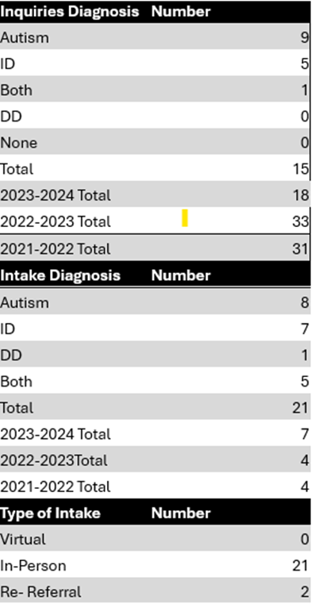

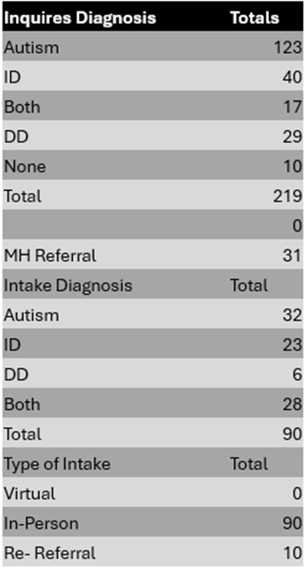

These numbers reflect over the **last 6 months: July – December 2024**

**ID Individuals Registered**

* As of 2024; December there are 1506 individuals registered with the Dauphin County ID/A system. Of those individuals, 5 reside in state centers or private intermediate care facilities, 224 are enrolled in Person/Family Directed Supports Waiver, (capacity 281). 136 are enrolled in Community Living Waiver (capacity is 151). 496 are enrolled in Consolidated Wavier (capacity 501). 237 are receiving base-funded services, and 408 are Supports Coordination services only.

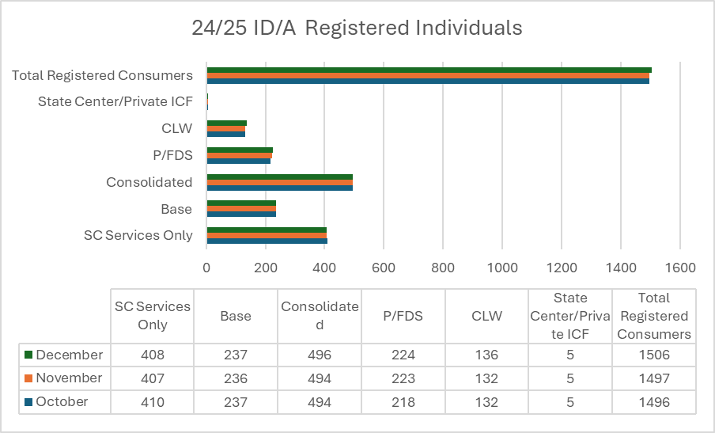

**PUNS**

* As of December 2024, there are 158 individuals in the Emergency category of the Prioritization of Urgency of Need for Services (PUNS), 87 individuals in the Critical category, 32 individuals in the Planning category, and a total of 277 individuals on the PUNS.

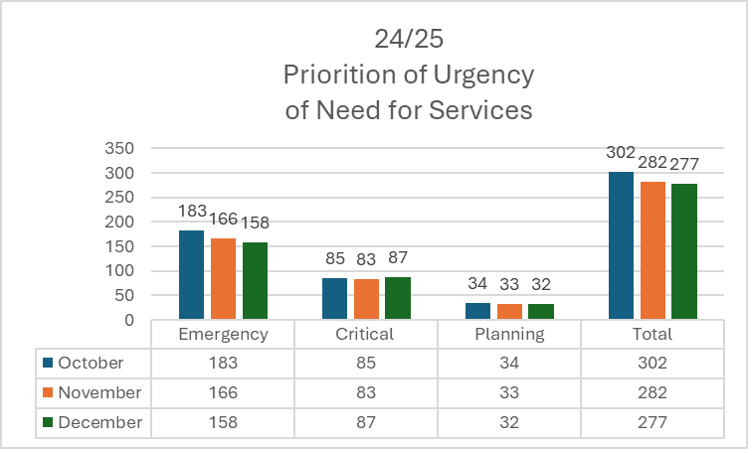

**Residential Planning**

* ADP is currently actively searching for residential placements for 26 individuals in need of residential services. Of these 26 individuals, 23 are currently enrolled in Consolidated Waiver and 9 require a Consolidated Waiver to meet their needs. Julie continues to work with CMU staff and to reach out to providers, to establish openings/locations, develop a process of open communication to streamline needs with providers and supports coordinators.
* ADP continues to struggle with finding safe, affordable housing options for individuals in need. In the month of November, ADP had 10 individuals experiencing homelessness, we are not providing base funding for living costs. The graph below shows individuals living in hotels in and the associated monthly costs to ADP. Referrals have been made to the 811 program, Dauphin County Housing Authority, and HELP Ministries for resources and training.

* We are working to identify individuals who can contribute a portion of their monthly hotel costs. Currently, we are assisting four individuals in securing apartments through the Housing Transition and Tenancy Sustaining services offered via the waiver. Four individuals found an apartment through the HTTS program.
* J Arvelo and children had hotel damages of $1334 and have moved into an apartment in Upper Dauphin. This amount is not in the monthly expense.
* Our goal for 2025 is to reduce the number of individuals residing in hotels to seven or fewer by the end of the fiscal year.

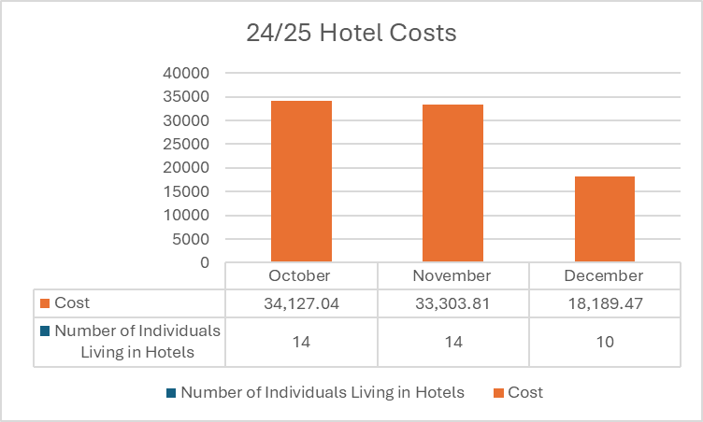

**Early Intervention**

**Committees:**

* Core Leadership Monthly Meeting-Discussed the survey update at the mid-point and next steps. We talked about what we need to do with the data and how to present it to providers. We discussed communication with providers about FGRBI.
* Transition Committee—EIC is the chair for this committee. Several of the members were sick or unable to attend. We discussed changes at the CAIU and annual evaluations. Another meeting will be scheduled with Amy Reed (C/P EIC), Karen Williams (CAIU supervisor), Michelle Straw (CAIU rep) and EIC to discuss the next steps for improving the annual/transition evaluation process. We also created a plan to update paperwork for families during the transition process. Next meeting will be in February. There will be a meeting with core leaders in January.

ELRC (Early Learning Resource Center) committee-shared updates and discussed collaboration.

**Meetings:**

* Fiscal interview for Verification-Ellen Castagneto (OCDEL advisor), Paul Geffert (Fiscal department head), and EIC
* EIC met with Laura Gray from PTS to discuss if the agency would be able to supply ST in Northern Dauphin and Social work services. We will re-connect after EIC can speak with Aspirations regarding increasing SW. Laura will discuss with her supervisor about ST.
* Dauphin/Cumberland/Perry EIC for our monthly meeting. We discussed FGRBI survey, SW services, CLT, Verification.
* Meeting with Chris and Jill (Pathways Forward EI supervisors) to prepare for the OCDEL Supervisory Interview.
* Interview with Ellen, Chris and Jill. We had many questions about how we handle Child Find, Evaluations, IFSP, procedures, etc
* SICC (State Interagency Coordinating Counsil) There was a family story. They talked about the Title 5 Block Grant and updated about OCDEL’s federal audit.
* Meeting with provider “Potentiality” to talk about concerns with paperwork.
* Quarterly Provider Meeting on 12/6/24. Tiffany Bogden present about Informed Clinical Opinion; Marci Walborn presented updates on Community Links; Kelly Rice talked about her trip to Africa to assist with therapy at a clinic. We talked about FGBRI, statewide updates, verification and safety. Next meeting in February.
* Kick-off webinar for Family Survey-to begin in January
* OCDEL requested another meeting with Emily Hackelman, Ellen Castagneto, Paul Geffert, and EIC. They shared resources and were concerned that there’s not a closer monitoring of MA and Waiver funding. EIC will coordinate with Sufyan for weekly reports to begin to monitor.
* All Staff Meeting

**Training:**

* Attended CAO training

**Annual Provider Monitoring:**

* Cherie Rodgers ST-completed in person and discussed her retirement. We formed a plan for her transition, and she will send a formal email to EIC. No improvement plan was issued.

**Verification:**

* Multiple and ongoing emails with providers and EI supervisors
* My main priority was to organize files to prepare for OCDEL’s verification
* Met with my OCDEL advisor to discuss verification questions.
* Met with Jill and Chris (EI supervisors) several times to prepare for verification.

**Important Projects/Other:**

* Billing issues addressed weekly.
* Continued monitoring of Centralized Referral System
* Continued addressing concerns from families and providers
* Monthly status updates and corrections from OCDEL to providers
* Scheduling and developing training opportunities
* Onboarding new therapists as needed
* Contract needs—during this month, we’re in the process of adding two independent contractors.
* Daily authorizations of services
* Gina Federico (EITA consultant), Amy Reed (C/P EIC) and I created and implemented a survey for each EI professional regarding the completion of training on the FBGRI Learning Path. We are continuing to gather feedback.

**Events:**

* None

**December Monthly EI Data**

For the month of December 2024, Early Intervention received 132 referrals, served 643 children - active with plan, served 60 children – at risk tracking, and closed 121 children. There were 0 reports made to ChildLine.

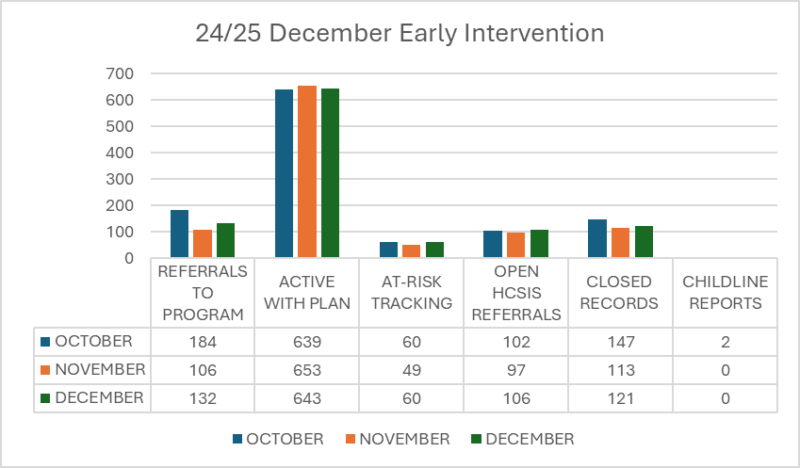

* All Staff Meeting-discussed budget information, staffing, new walk-in center updates, policy for inclement weather,
* ID/A continues to expand the FDSS program and offers increased opportunities for physical fitness, recreation/socialization, and mental/emotional well-being for all registered individuals.
* ADP continues to collaborate with other service systems within Dauphin County including CYS and Mental Health to meet the needs of individuals with complex needs and enroll them in waiver programs as capacity to do so is available.
* ADP has continued outreach efforts to residential providers for several children and young adults that are soon transitioning out of the children’s system.
* ADP also continues to offer base funding to help support children whenever possible until waiver capacity is available.

**Mental Health Monthly Report**

**December 2024**

**Staffing**

* Vacancies – Program Specialist 2 – Children’s Mental Health and Program Specialist 2 – Housing Transition Coordinator

**Events, Activities, Trainings**

* DHS Capacity Building Institute
* Annual PA Early Psychosis Conference
* Children and Youth Services Holiday Store
* Community Support Program Holiday Party

**ROST Priorities Updates**

* BH Crisis Response Services – Connections Health Solutions Emergency Behavioral Health Walk-In Center began offering mobile services 12/4/24 and the walk-in center opened to adults on 12/11/24; ongoing work to engage and promote services to stakeholders
* Suicide Prevention – NAMI Central PA participated in several community events to raise awareness and provided a presentation to Dauphin County Prison on NAMI programs.
* SDoH/Housing
  + PATH – Downtown Daily Bread homeless case management continues to enrolled new individuals. The Homeless Outreach worker in Crisis Intervention moved on to another employment opportunity in December. Hiring a replacement is underway.
  + Bridge – 1 individual transitioned to a permanent voucher, 1 received a voucher and is searching for an apartment, and 3 applicants were submitted for a subsidy
  + SOAR – currently serving 6 individuals with 35 individuals pending
  + Sycamore Homes – Delayed until March 2025
  + Shelter Plus Care – In process of submitting 6 applicants
  + Social Determinants of Health



* + Family Support Services – “emergency funds” for shelter, transportation, medication, food, clothing, etc continues to be utilized by the three case management agencies as seen below:

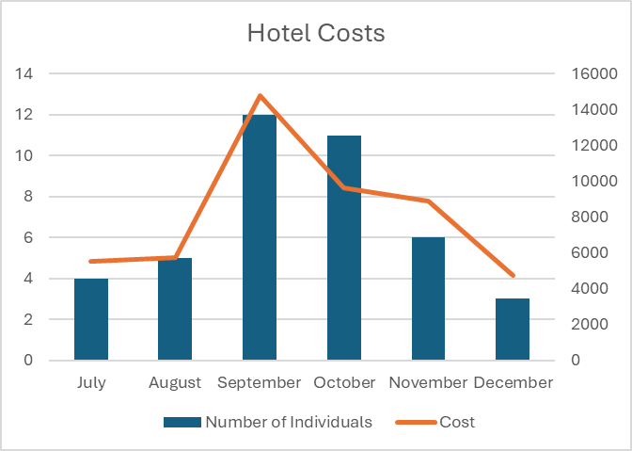



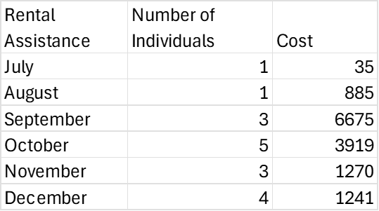



**Other Grant/Reinvestment Updates**

* The JEREMY Project – Transitional Age Youth Program

In December, participants were offered the opportunity to participate in several groups on community socialization that included dine out events, dinner and a movie, special showing of the Cirque Musica Holiday Wonderland at the Hershey Theater, Christmas ceramics at the local art studio, bowling day, game day, Christmas cookie decorating day, and trivia day. Jeremy Project held two holiday celebrations and participants were fortunate to receive all requested gifts from the JEREMY Project Angel Tree. A holiday baking event was also held. One volunteer opportunity was offered at Lords Angels Helping Moms and Babies.

|  |  |
| --- | --- |
| **Total Served** | **24** |
| **Currently Opened** | **18** |
| **Pending Enrollment** | **6** |
| **New Enrollments** | **1** |
| **Discharged** | **1** |
| **Individual Sessions Held** | **18** |
| **Groups Offered** | **13** |

* CAPSTONE – first episode psychosis program

October 1, 2024 – December 31, 2024

|  |  |
| --- | --- |
| Referred | 19 |
| Newly Enrolled | 7 |
| New Admit Adults | 30 |
| New Admit under 18 | 1 |
| Current Enrolled | 31 |
| Current Enrolled Adults | 28 |
| Current Enrolled under 18 | 3 |
| Discharged Adults 21+ | 3 |
| Discharged under 21 | 2 |
| #s served (census + DCs) | 36 |
| % with no IP psych | 83.8% |
| % with no arrests | 96.7% |

**Outcome Data**

* **YWCA Support Employment – 10/1/24-12/31/24**

|  |  |  |
| --- | --- | --- |
|  | **Performance Indicators** | **Quarterly** |
| **1** | **80% program participation rate in employment or occupational goals** | 6/6 100% |
| **2** | **60% employment placement rate** | 3/6 =50% |
| **3** | **60% retention in employment for 3 months** |  |
| **4** | **75% non-recidivism rate of ex-offender served** | 6/6 100% |
| **5** | **70% no less than minimum competitive employment wage** | 3/3= 100% |
| **6** | **All consumers will receive employer contact within the first 60 days of enrollment** | 6/6 = 100% |
| **7** | **60% employed within the first 90days of service** | 2/6= 33% |
| **8** | **33% Able to take care of their needs** | 6/6 = 100% |
| **9** | **60% Better in work or school** | 5/6= 100% |

|  |  |  |
| --- | --- | --- |
| **10** | **37% rate their mental health recovery higher than fair (good to excellent)** | 4/6= 89 % |

**Children’s Mental Health**

* Access Issues
  + IBHS and psychiatry continue to have the longest average wait times; however, some outpatient providers are reporting immediate or less than two weeks access for psychiatry. Wait times are highly variable depending upon insurance, need IBHS services, and choice of provider. The average wait time for family based mental health services is trending upward and is now over three weeks.
  + CMU continues to open all eligible children in admin case management and refer for blended care management if needed. CMU continues to have a significant waiting list for BCM for children:

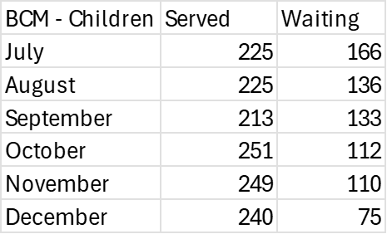

* RTFs and CRR Host Homes– Work continues to plan for discharge for those currently residing in RTFs and offer all available community-based supports for those at risk of placement.

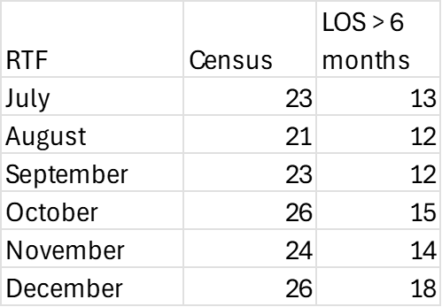

**Adult Mental Health**

* **State Hospital / Extended Acute Care**

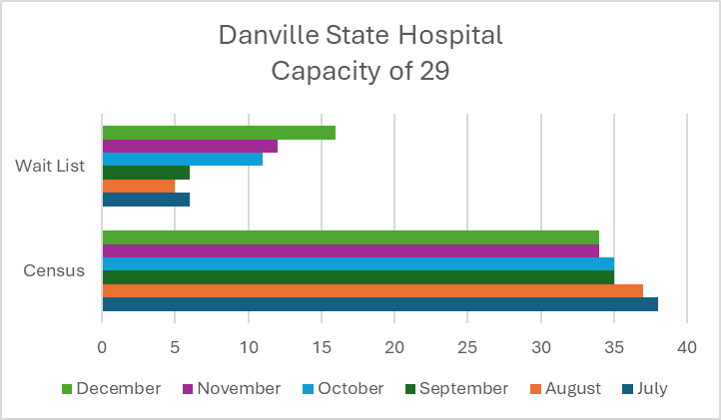

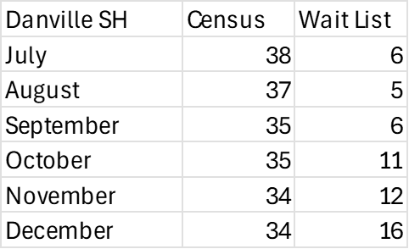

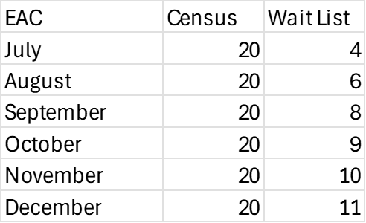

* **Access Issues**
  + Residential services continue to have significant wait times

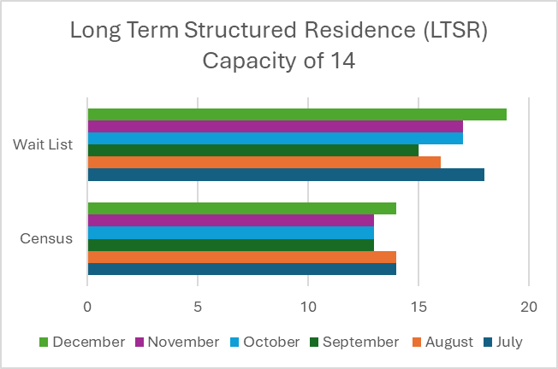

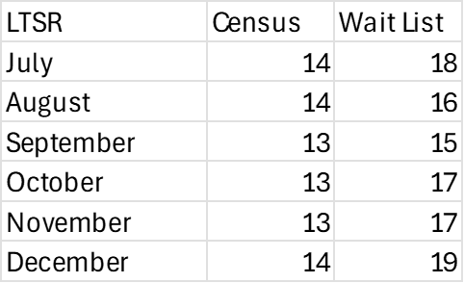

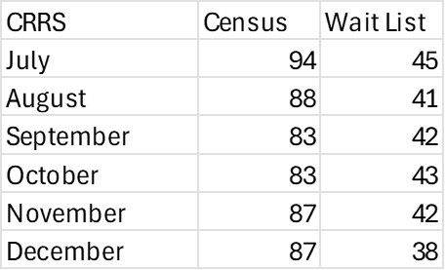

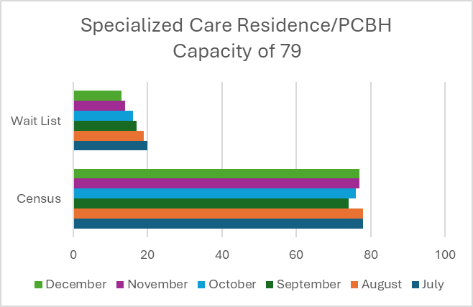

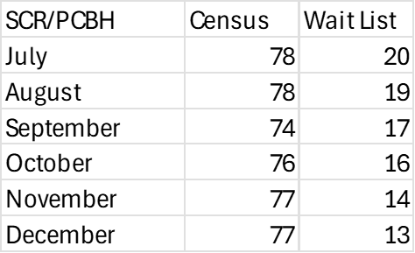

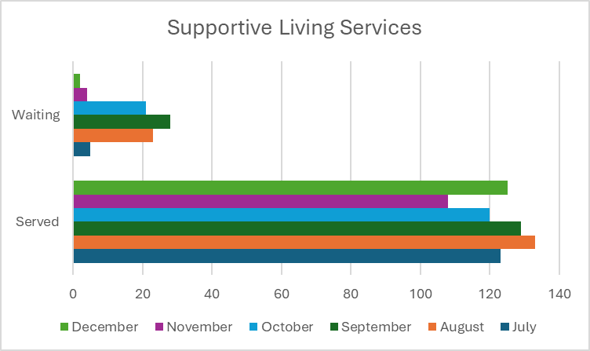



* + **Targeted Case Management also continues to have a significant wait list**

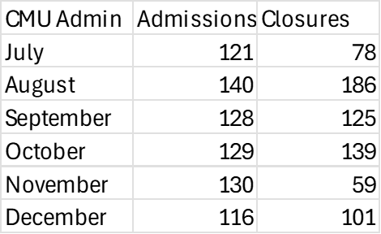

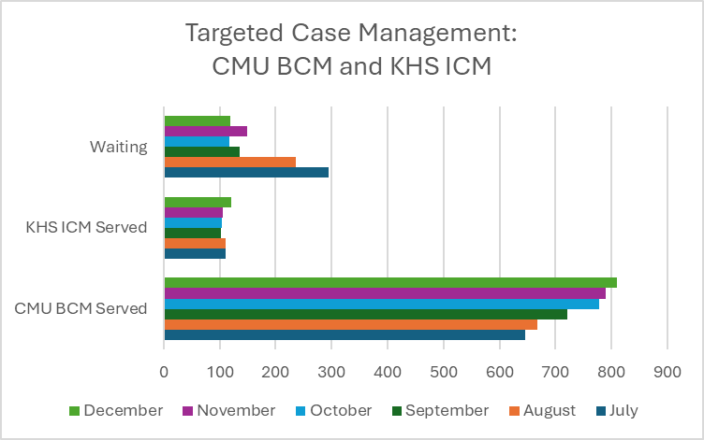

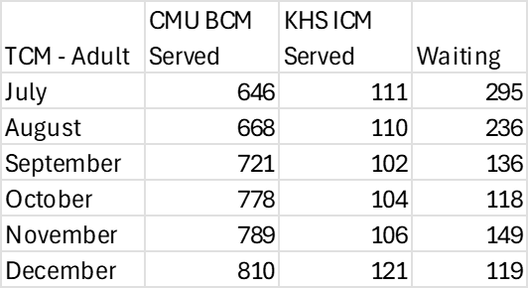

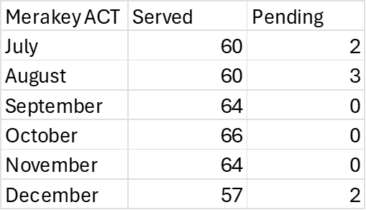

* + Wait times for outpatient therapy and psychiatry are improving with some providers reporting immediate openings. No current wait for partial hospitalization, social rehabilitation, peer support, psychiatric rehabilitation, supported employment
* **Involuntary Outpatient Orders**

|  |  |  |  |
| --- | --- | --- | --- |
| Month | Total individuals on an active involuntary outpatient (IVOP) commitment order | IVOP Orders expired this month | New IVOP Orders this month |
| July | 0 | 2 | 0 |
| August | 0 | 0 | 0 |
| September | 0 | 0 | 0 |
| October | 0 | 0 | 0 |
| November | 1 | 0 | 1 |
| December | 1 | 0 | 1 |

* **Incidents – Children**

|  |  |  |  |  |  |  |
| --- | --- | --- | --- | --- | --- | --- |
| **Incident Type** | **July** | **August** | **September** | **October** | **November** | **December** |
| Restraint with Injury | 2 | 2 | 0 | 0 | 0 | 0 |
| Seclusion | 0 | 0 | 0 | 0 | 0 | 0 |
| Missing Person | 0 | 2 | 0 | 2 | 1 | 0 |
| Serious Illness/Injury | 0 | 0 | 0 | 7 | 5 | 2 |
| Abuse/Neglect Allegation | 6 | 1 | 0 | 3 | 0 | 0 |
| Self-Injurious Behavior | 2 | 0 | 1 | 0 | 0 | 0 |
| Serious Physical Aggression | 3 | 0 | 0 | 0 | 4 | 0 |
| Sexual Acting Out | 2 | 0 | 0 | 0 | 0 | 0 |
| Police/Fire Event | 0 | 0 | 1 | 1 | 1 | 1 |
| Suicide Attempt | 0 | 1 | 1 | 0 | 0 | 0 |
| Death | 0 | 0 | 0 | 0 | 0 | 0 |
| Other | 0 | 0 | 0 | 0 | 2 | 0 |
| **Total Number of Incidents** | **15** | **6** | **3** | **13** | **12** | **3** |

* **Incidents – Adults**

|  |  |  |  |  |  |  |
| --- | --- | --- | --- | --- | --- | --- |
| **Incident Type** | **July** | **August** | **September** | **October** | **November** | **December** |
| Death by drug overdose MH | 0 | 0 | 0 | 0 | 0 | 0 |
| Death by drug overdose IDA | 0 | 0 | 0 | 0 | 0 | 0 |
| Death | 1 | 0 | 1 | 0 | 2 | 2 |
| Attempted Suicide by Overdose | 1 | 0 | 2 | 0 | 0 | 0 |
| Serious Illness Requiring Hospitalization | 37 | 29 | 22 | 33 | 22 | 35 |
| Incarceration | 15 | 13 | 25 | 20 | 16 | 7 |
| Criminal Event Involving the Police | 1 | 7 | 1 | 3 | 2 | 3 |
| Inpatient Psychology Care | 12 | 12 | 3 | 8 | 10 | 7 |
| Serious Acts of Violence | 2 | 1 | 1 | 1 | 1 | 2 |
| Resident to Resident Abuse | 0 | 0 | 1 | 0 | 0 | 0 |
| Allegations of Abuse by Staff | 2 | 2 | 0 | 6 | 1 | 0 |
| Fire or other Disasters | 0 | 0 | 1 | 1 | 0 | 0 |
| Communicable Disease | 0 | 0 | 1 | 0 | 0 | 0 |
| Medication Error | 4 | 3 | 3 | 6 | 7 | 3 |
| Injury | 0 | 0 | 1 | 0 | 0 | 0 |
| Misuse of Funds | 0 | 0 | 0 | 0 | 0 | 0 |

|  |  |  |  |  |  |  |
| --- | --- | --- | --- | --- | --- | --- |
| Missing Person | 0 | 2 | 0 | 0 | 1 | 0 |
| **Total Number of Incidents** | **75** | **69** | **69** | **78** | **62** | **60** |

**Crisis Intervention Services – December 2024**

* Crisis staff answered 2,041 of 2,363 incoming calls (86%) in December of 2024.
* Crisis Intervention served a total of 146 individuals. Of those, 55 were first-time consumers of the program, while 91 had at least one previous contact.
* Crisis provided 68 mobile services with each service averaging 1.5 hours.
* Crisis provided 240 telephone services with each service averaging .60 hours.
* Crisis provided 6 walk-in services with each service averaging .70 hours.

* Crisis also provided an additional 108 hours of collateral contacts which consist of other phone calls and interactions that are not defined by state regulations.
* In addition, a total of 92 hours was collectively spent working on bed searches, insurance authorizations and other activity related to commitments.
* Crisis received 20 referrals from the three emergency departments (UPMC Harrisburg, UPMC Community General, and Penn State Hershey) in Dauphin County.
* Crisis received 18 referrals from police.
* Crisis received 2 referrals from DCP.
* Crisis received 1 referral from 988/Lifeline.
* Crisis referred 4 individuals to the Connections Walk-in Center.
* Crisis referred 9 individuals to Connections Mobile Services.
* 302 Data for **November 2024**:
  + 3 voluntary (201) admissions.
  + 82 petitioned 302’s:
    - 55 were approved (67% of those petitioned), and 51 were ultimately admitted for treatment (93% of approvals). There was 2 that required a 303 to be completed prior to transfer to a psychiatric facility.
    - 27 were denied (33% of those petitioned). 7 of those resulted in 201’s being signed, and 1 was admitted for medical treatment.
  + Breakdown of 302 petitioners:
    - 31 were petitioned by physicians (includes ER doctors, psychiatrists at PPI and doctors on medical floors).
    - 12 were petitioned by police officers.
    - 5 were petitioned by a co-responder.
      * + Of those petitioned by police/co-responders, 8 were denied, and 2 of the denials signed a 201.
    - 16 were petitioned by friends and family members.
    - 17 were petitioned by MH workers (includes Crisis, CMU, Keystone and ACT staff).
    - 1 was petitioned by an EMT.
* 302 Data for **December** **2024**:
  + 3 voluntary (201) admissions.
  + 55 petitioned 302’s:
    - 40 were approved (73% of those petitioned), and 38 were ultimately admitted for treatment (95% of approvals).
      * There were no 303 requests in ED’s during December.
    - 15 were denied (27% of those petitioned). 5 of those resulted in 201’s being signed, and 2 were admitted for medical treatment.
  + Breakdown of 302 petitioners:
    - 24 were petitioned by physicians (includes ER doctors, psychiatrists at PPI and doctors on medical floors).
    - 5 were petitioned by police officers.
    - 2 were petitioned by a co-responder.
      * + Of those petitioned by police/co-responders, 3 were denied.
    - 17 were petitioned by friends and family members.
    - 7 were petitioned by MH workers (includes Crisis, CMU, Keystone and ACT staff).

1. **Presentation: Draft MHADP FY 23-24 Annual Plan**



1. **Committee Reports**

Executive Committee- None

Nominating Committee- None Review of Vacancies

Intellectual Disabilities Committee

Mental Health Committee

1. **Fiscal Report Briefing**
2. **Community Input/Other Business/Motions/Adjournment**
3. **Next Public Board Meeting: March 25, 2025 at 8:30AM, virtual meeting- Presentation: TBD**

**Respectfully Submitted,**

London Crane

Administrative Assistant, MHADP